Abstract template for the SiQEW2026 & ICOSS2026

Author First^{1,2}, Author Second¹, Author Third², and Author Last¹
¹Affiliation First, Brief Address
²Affiliation Second, Brief Address

Welcome. This is the template for the abstract for the Silicon Quantum Electronics Workshop 2026 (SiQEW2026) and International Conference on Spin Shuttling 2026 (ICOSS2026). Each abstract must include title, author list, affiliations, and main text. Reference list, color figures, and tables can also be included. The main text should be single column single spaced, written in English, and should not exceed one page. Authors can submit their abstract by uploading the abstract file (pdf or word) on the abstract submission page (https://softconf.com/p/siqew2026). If there is any technical issue, you can contact us via email to secretariat@siqew2026.com.
We are looking forward to your submission.
Example Reference list

- Loss, Daniel, and David P. DiVincenzo., Physical Review A 57, no. 1, 120-26 (1998).
- Veldhorst, M. et al., Nature Nanotechnology. 9, no. 12, 981-85 (2014).
- Hicks, R., Kobrin, B., Bauer, C. W. & Nachman, B. et al., Phys. Rev. A 105, 012419 (2022).
- Kandala, A., Temme, K., Córcoles, A.D. et al., Nature 567, 491–495 (2019).

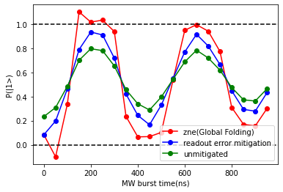
Example Figure. Attaching a figure is optional but highly recommended. Both using figure containing technical research data or showing schematics of the research idea are fine.

